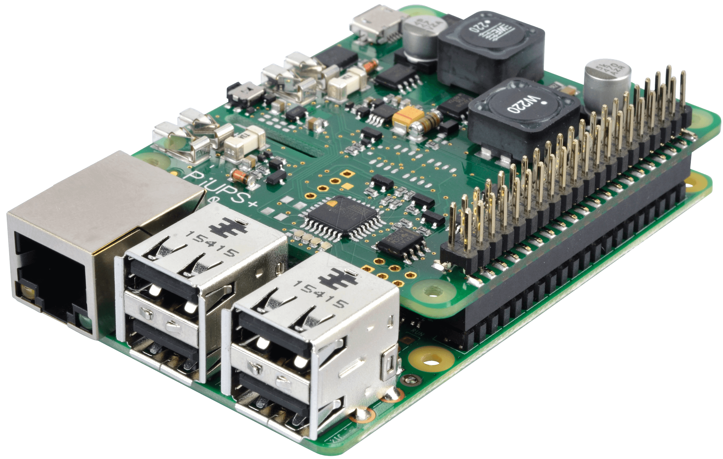Raspberry Pi

Anthony Mellon

Platforms and Devices

Paul Admiraal

16/05/19

Table of Contents

The Raspberry pi 2

History of the raspberry pi 3

What operating system can go on the raspberry pi? 3

WHat are the costs 4

Alternatives 4

Uses 4

bibliography 5

# The Raspberry pi

The raspberry pi is a series of small single-board computers. Most Raspberry Pi’s have 26 pins. Two of these pins are +3.3 V, two are +5 V, and 5 are ground pins. Some models have an extra 14 pins which includes 3 more ground pins.

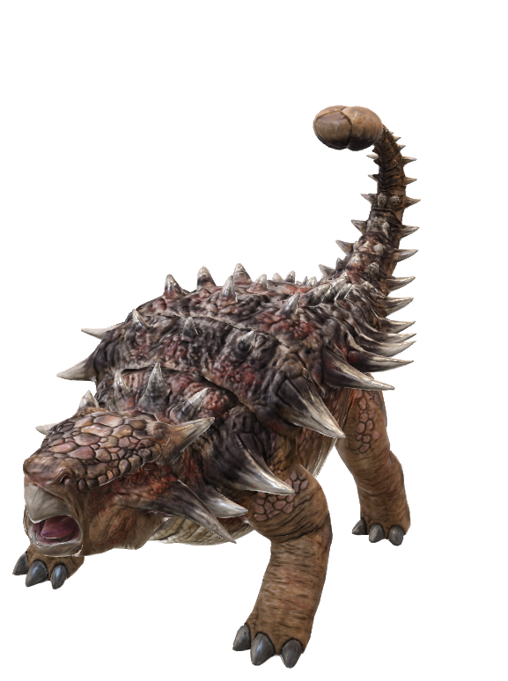

Think a school report that looks this good has to be difficult to format? Think again! To easily apply any text formatting you see in this document with just a tap, on the Home tab of the ribbon, check out Styles.

“This quote is bold and distinctive. The Style Gallery includes items that are designed to coordinate with the look of your document.”

Some of the sample text in this document indicates the name of the style applied, so that you can easily apply the same formatting again. For example, this is the Normal style.

On the Insert tab, the galleries include items that are designed to coordinate with the overall look of your document. You can use these galleries to insert tables, headers, footers, lists, cover pages, and other document building blocks. When you create pictures, charts, or diagrams, they also coordinate with your current document look.

Find even more easy-to-use tools on the Insert tab, such as to add a hyperlink, insert a comment, or add automatic page numbering.

### History of the raspberry pi

The early concepts of the Raspberry Pi were based on the Atmel ATmega644

### What operating system can go on the raspberry pi?

Want to insert a picture from your files or add a shape, text box, or table? You got it! On the Insert tab of the ribbon, just tap the option you need.

Use styles to easily format your Word documents in no time. For example, this text uses the Normal style. Styles in this document have been customized to match the text formatting you see on this page. On the Home tab of the ribbon, check out Styles to apply the formatting you need with just a tap.

Use SmartArt and Charts to display your data. Go to the Insert Tab and you’ll find those two options. Choose which one suits your needs.

### WHat are the costs

### Alternatives

### Uses

## bibliography

Remember to cite any information you used.

On the References tab, in the Citations & Bibliography group, click Insert Citation for the option to add sources and then place citations in the document.

* **Reference 1**
* **Reference 2**